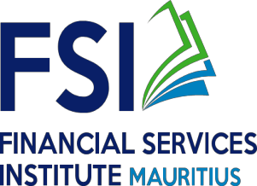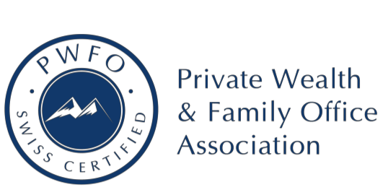

REGISTRATION FORM
Private Wealth and Family Office Services (Project-Based Learning) : Global Passport to the Top in Financial Planning, Wealth Services and Family Office

Date: 24th AUGUST 2020
NAME OF ORGANISATION
ADDRESS
CONTACT NO & EMAIL
PARTICIPANT DETAILS | SURNAME:
 | FIRST NAME:
DESIGNATION
NATIONAL IDENTITY CARD
CONTACT TEL & EMAIL OF
PARTICIPANT (If different from above)
PREFERRED MODE OF PAYMENT  (please tick as appropriate to enable us to issue appropriate invoice) | CHEQUE | BANK TRANSFER

A copy of National Identity Card of participant should be attached.

NOTE:
Completed Registration Forms must reach us by email on registrations@fsimauritius.com by latest on

Tuesday 18 August 2020.
Should you have any queries, please do not hesitate to contact us on 4011208. Thank You.

